**Overview**

**EI will send a completed and updated, age-anchored COS B to summarize a child’s present levels of development (PLOD) for all children (even if they are not potentially eligible for ECSE) so that:**

* + Parents will leave EI with a current write-up of their child’s PLOD
  + EI/ECSE can develop an accurate exit /entry Summary Statement (rating)

**EI no longer needs to send an Exit COS A to the LEAs for Special Education eligibility.**

**COS B Format in Welligent**

The COS B for transition, also known as the Exit COS B can be found in Welligent and at <https://sherlockcenter.ric.edu/files/ei-ifsp-cos-bpdf>

**COS B Information Must be Current**

The Exit COS B **must** contain current information. For example, if the child has acquired a new skill(s) between the time the IFSP COS was written and when it is sent to the LEA, those new skills must be included before sending to the LEA.

**COS B Information Must be Comprehensive**

Early Intervention providers should be sure to respond to all the guidance prompts embedded in the COS form.

**Guidance Part C 619 Part of the Process**

LEA’s will continue to use the COS A, B, and C process. The LEA will take EI’s age-anchored COS B and cut and paste information into their COS A formatted by skill bundles. The COS A will be updated at the referral meeting, becoming the COS B. COS C will continue to be completed at the IEP meeting, or by the Early Intervention provider if the child does not transition to the school department. Please be sure the LEA gets the Exit COS for transition at least 7 days before the referral meeting.

**Materials**

There are several different guidance materials so that everyone can use the one(s) that best fits their style of work. It is important for all staff to **use at least one** of these documents to avoid “drift” from the prompts that address a wide range of functional skills.

**Graphic**

We have included a guidance **graphic** developed by our national technical assistance center, ECTA, which depicts the skill bundles within each outcome area. It is meant to be used with parents, caregivers and IFSP team members to ensure the COS (for both entry and exit) is comprehensive. We are providing a variety of companion documents to assist staff in completing the Exit COS B so that EI providers are certain to address all the prompts, ensuring that write-ups are rich and comprehensive.

**Checklist**

We have created a guidance **checklist** with the skill bundle prompts. This is primarily for EI staff to keep handy to guide both conversations and write-ups. Functional skills and behaviors that do not fit these skill bundle areas can be written in the *Other Notable Observations and Information* section of the COS.

**Decision Tree**

Finally, we have included a new version of the **Decision Tree**. This version highlights the statement, not the number, and provides prompts for the team to reflect on what evidence they have to support each tier, as you move down the tree. Using this Decision Tree will help RI Early Intervention to have more accurate, evidence-based data, and provide parents with an easy way to understand how summary statements are determined. It will soon be required for all EI staff to use the Decision Tree when arriving at summary statement ratings.

**Exit COS C Developed with ECSE**

If EI providers have any disagreement with the ratings developed in collaboration with the ECSE IEP team, you need to complete your own COS C for EI data entry, with the ratings you believe are accurate (using the Decision Tree). This is important in ensuring EI outcomes data is accurate while not impacting Part C 619 entry data.

This guidance was originally shared on *12/28/22 and updated 6/10/24.*

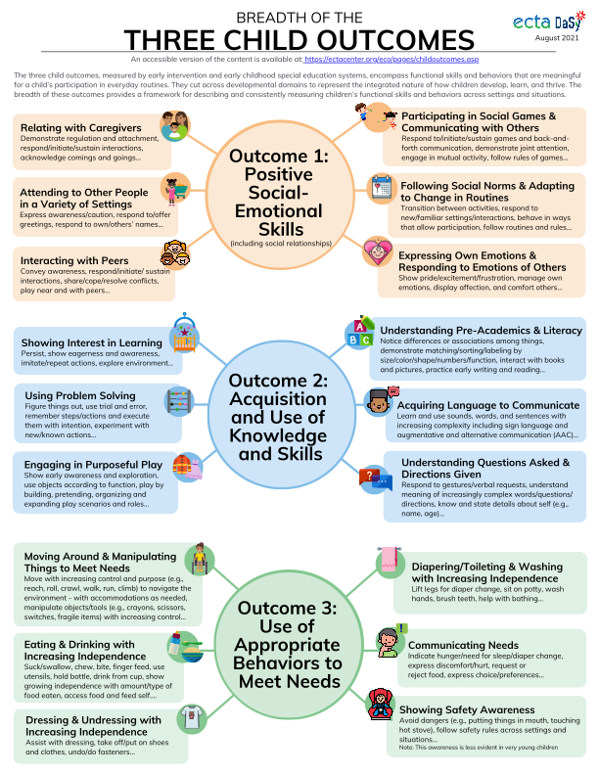

*This is a checklist to guide EI providers and IFSP team members in writing comprehensive Present Levels of Development /Child Outcome Summary (COS) Write-ups. It is not a requirement that providers use this. It is meant to be a companion document when gathering information from caregivers.*

|  |  |
| --- | --- |
| **Outcome 1: Positive Social Emotional Skills (Including Social Relationships).** *Considers how the child relates to adults and other children. The outcome is measured based on how the child forms secure relationships with adults and other children, expresses emotions and feelings, learns rules and expectations, and interacts socially.* | |
| *Were the following skill areas addressed in the child’s COS write up?*  *Check off items as the IFSP team addresses each prompt.* | |
|  | **Relating with caregivers** *(attachment, separation, regulation, respond to/initiate/sustain interactions, respond to caregiver’s touch, track caregivers visually…)* |
|  | **Attending to others in a variety of settings** *(awareness, caution, respond to/offer greetings, respond to own/others’ names…)* |
|  | **Interacting with peers** *(awareness, respond/initiate/sustain interactions, share, cope and resolve conflicts, play next to/with peers…)* |
|  | **Engaging in social games and communication with others** *(respond to/initiate/ sustain games and social communication, engage in mutual activity, joint attention, use signs/language to greet and engage others and to respond to others statements, prompts and questions…)* |
|  | **Adapting to changes in the environment or routines** *(transition between activities, respond to new/familiar settings/interactions, behave in ways to participate, follow rules…)* |
|  | **Expressing own emotions and responding to the emotions of others** *(show pride/excitement/ frustration, display affection, acknowledge/ comfort others…)* |
|  | **Interacting with peers** *(awareness, respond/initiate/sustain interactions, share, cope and resolve conflicts, play next to/with peers…)* |
| **Outcome 2: Acquiring and Using Knowledge and Skills:** *Involves thinking and reasoning, remembering, problem solving, using symbols and language, and understanding the physical and social world. Considers the child’s exploration and imitation, understanding of object permanence, symbolic representation, numbers, classification, spatial relationships, expressive language and communication, and for older children, early literacy.* | |
| *Were the following skill areas addressed in the child’s COS write up?*  *Check off items as the IFSP team addresses each prompt.* | |
|  | **Showing interest in learning** *(track objects/people, persist, show eagerness and awareness, imitate and repeat actions, explore environment…)* |
|  | **Using problem solving** *(figure things out, trial and error, remember steps/actions, use purposeful actions, experiment with known and new actions…)* |
|  | **Engaging in purposeful play** *(early awareness and exploration, functional object use, use of household objects, construction, pretend, make believe play scenarios…)* |
|  | **Demonstrates cognitive and literacy concepts** *(discriminates between objects, shows visual preference, shifts attention, interest in/interacts with books, differences/associations among things, matching/sorting, size/color/shape/ numbers, actions with pictures and books, early writing…)* |
|  | **Uses language to communicate** *(babbling, progressing from sounds to words/signs, imitates others sounds/signs, points or gestures to communicate interest, words/signs to communicate thoughts and interest)* |
|  | **Understanding questions asked and directions given** *(responds to verbal/signed gestures & requests, understand meaning of increasingly complex word/questions/directions…)* |
| **Outcome 3: Taking Action to Meet Needs:** *Involves taking care of basic needs, getting from place to place, using tools like a fork, toothbrush, or crayon, and for older children, contributing to their own health and safety. The outcome is measured based on a child’s ability to integrate motor skills to complete tasks, self-help skills (e.g., dressing, feeding, grooming, toileting, and household responsibilities), and “act on the world to get what one needs.”)* | |
| *Were the following skill areas addressed in the child’s COS write up?*  *Check off items as the IFSP team addresses each prompt.* | |
|  | **Moving around to meet needs** (early movements and control to rolling, sitting, crawling, walking, running, jumping, climbing) |
|  | **Using materials for effect** (manipulating small items/toys, turning knobs, unscrewing lids, putting pieces in a puzzle, using tools, crayons) |
|  | **Eating and drinking with increasing independence** (suck/swallow, chew, bite, finger feed, use utensils, hold bottle, drink from cups, amount type of food…) |
|  | **Dressing and undressing with increasing independence** (assist with dressing, take off, put on shoes and clothes, undo/do fasteners…) |
|  | **Diaper/toileting & washing with increasing independence** *(*lift legs, sit on potty, wash hands, brush teeth, help with bathing …) |
|  | **Communicating needs** (how does child indicate hunger, need for diaper change, sleep, express discomfort, hurt, need for help, request/reject food, express choice…) |
|  | **Showing safety awareness** (avoid dangers – stairs, stove, road, seatbelt…) |
| Other Notable Observations and Information | |
|  | |



