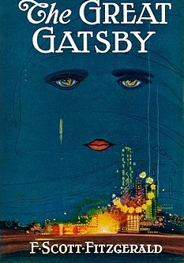

The Great Gatsby

By F. Scott Fitzgerald

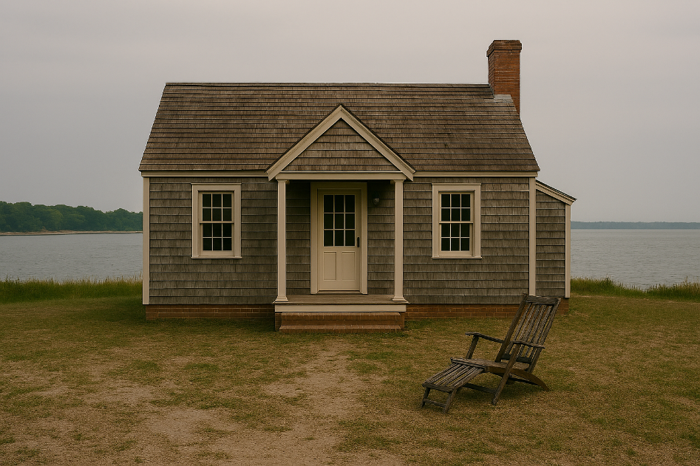

1. A New Life

Nick Carraway comes from far away. He fought in the war, and he wants to start a new life. He is a thoughtful and honest man.

Nick rents a small house in a place called West Egg. His small house is next door to a huge mansion.

The man who lives in the mansion is named Jay Gatsby. Gatsby has lots of parties, but Nick does not go to them. At night, Nick sits in his lawn chair. He sees people going to the parties.

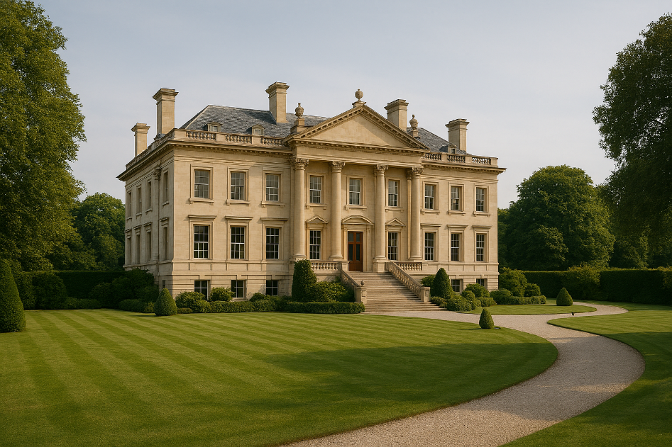

2. Daisy and Tom

Nick goes to a town nearby. It is called East Egg. He visits his cousin, Daisy. Daisy is charming and gentle. She seems to have everything she might want.

Daisy’s house is beautiful and quiet. There are big sunny windows. Everything looks expensive.

Daisy’s husband is named Tom. Tom is rude and mean.
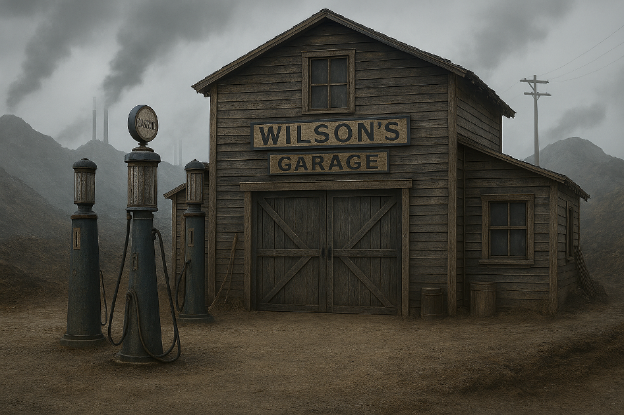

3. The Valley of Ashes

Tom brings Nick to visit New York City. On the way, they stop at a garage. The garage is in a very ugly place called the Valley of Ashes. There are piles of ashes from nearby factories.

George Wilson owns the garage. He is hardworking but sad. He loves his wife very much. He does not have a lot of money.

George’s wife is named Myrtle Wilson. She is a bold, loud person. She and Tom are having an affair.



4. Gatsby’s Party

Nick gets an invitation. His neighbor Gatsby wants him to come to a party.

Nick goes to the fancy party. There is a lot of food. One room has a large band and dancing. Another room is quiet and has a piano. A lot of people come to Gatsby’s house for the parties.

Gatsby likes to spend money on the parties. He hopes it will make people like him.

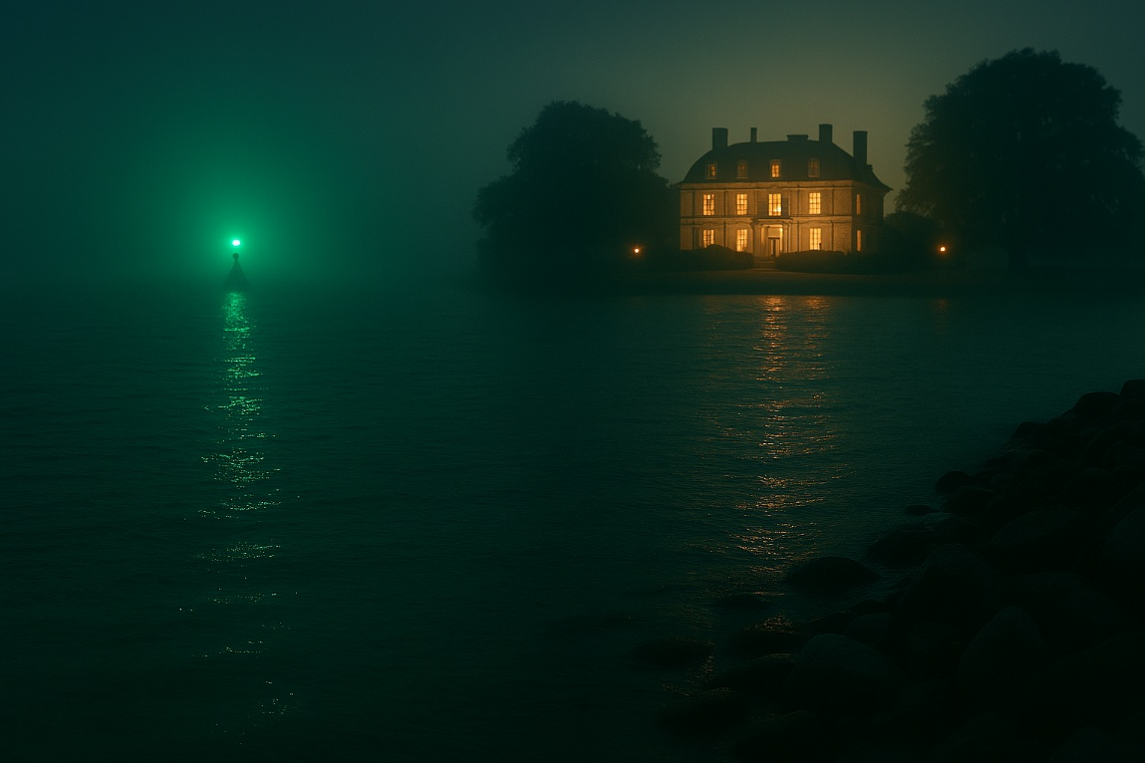

5. Gatsby’s Hopes

Nobody at the party really knows Gatsby. He is generous and secretive. Some people think Gatsby might be a war hero. Other people think Gatsby might be a criminal.

Gatsby trusts Nick. He tells Nick that he knew Daisy a long time ago. He was in love with her then, and he is still in love with her.

Gatsby can see a green light from his porch. The green light is a lamp post at Daisy’s house. He stares at the green light and hopes that he can be with Daisy one day.

6. In the Cottage
Nick arranges a secret meeting between Daisy and Gatsby. The meeting will be in Nick’s cottage. Gatsby fills the house with flowers. He is so nervous that he knocks over an old clock.
The meeting is awkward at first. Then Gatsby and Daisy are happy. They feel close again.
Gatsby believes Daisy will leave Tom to be with him.
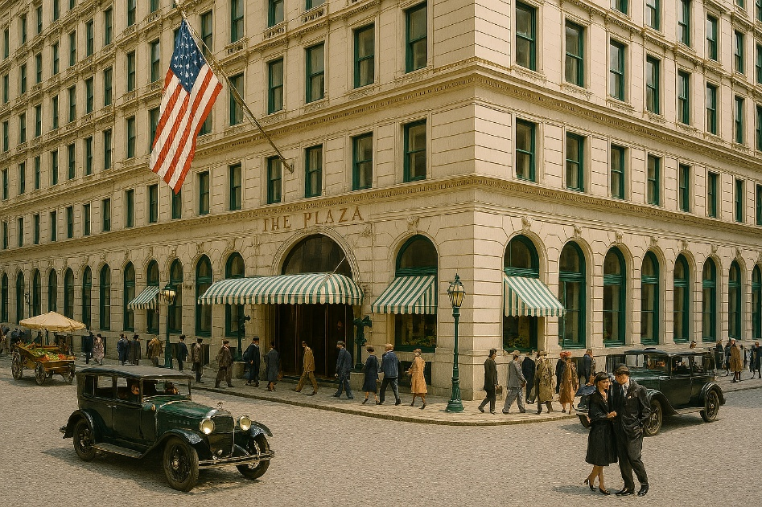

7. The Argument
Daisy, Tom, Nick, and Gatsby travel to New York City. They stay in the Plaza Hotel. It is very hot in the hotel. Everyone is in a bad mood.
Tom and Gatsby argue about who Daisy really loves.

Daisy can’t decide. She loves Gatsby. But she likes the life she has.



8. The Accident
Daisy and Gatsby drive home together. Daisy is driving Gatsby’s fancy yellow car.

In the Valley of Ashes, Daisy hits Myrtle by accident. Myrtle is dead.

Witnesses tell George that Myrtle was hit by a yellow car.

Tom tells George that the yellow car belongs to Gatsby.

9. Revenge
George believes Gatsby killed Myrtle on purpose. He also thinks Gatsby was having an affair with Myrtle.

George goes to Gatsby’s Mansion and shoots Gatsby.

Then George kills himself.

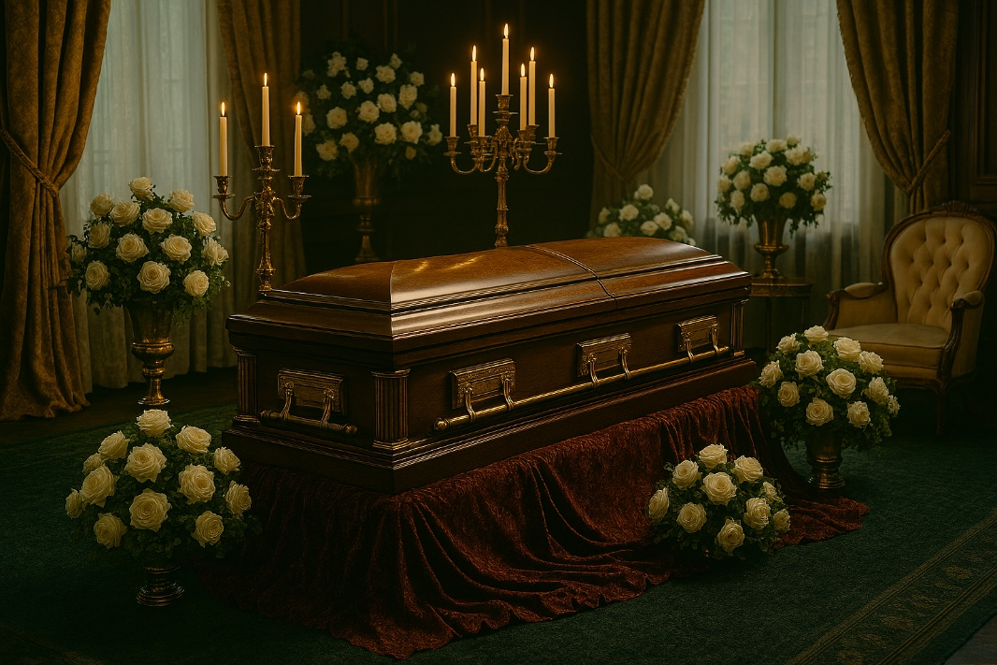

10. The Funeral

Nick goes to Gatsby’s funeral. Very few people go to the funeral. Lots of people liked Gatsby’s parties, but they did not come to his funeral.

Nick thinks the people in West Egg and East Egg are not nice people. He doesn’t like the type of life these people have. This new life is not for him.

He returns to the place he came from.

Disclaimer
This Adapted Literature resource is available through the Paul V. Sherlock Center on Disabilities Resource Library. The text and was adapted from the original source. Graphics were created by Copilot AI, March 2026. These resources are provided for teachers to help students with severe disabilities participate in the general curriculum. Please limit the use and distribution of these materials accordingly.

Paul V. Sherlock Center on Disabilities / RI College
600 Mt. Pleasant Avenue, Providence RI 02908 www.sherlockcenter.org

