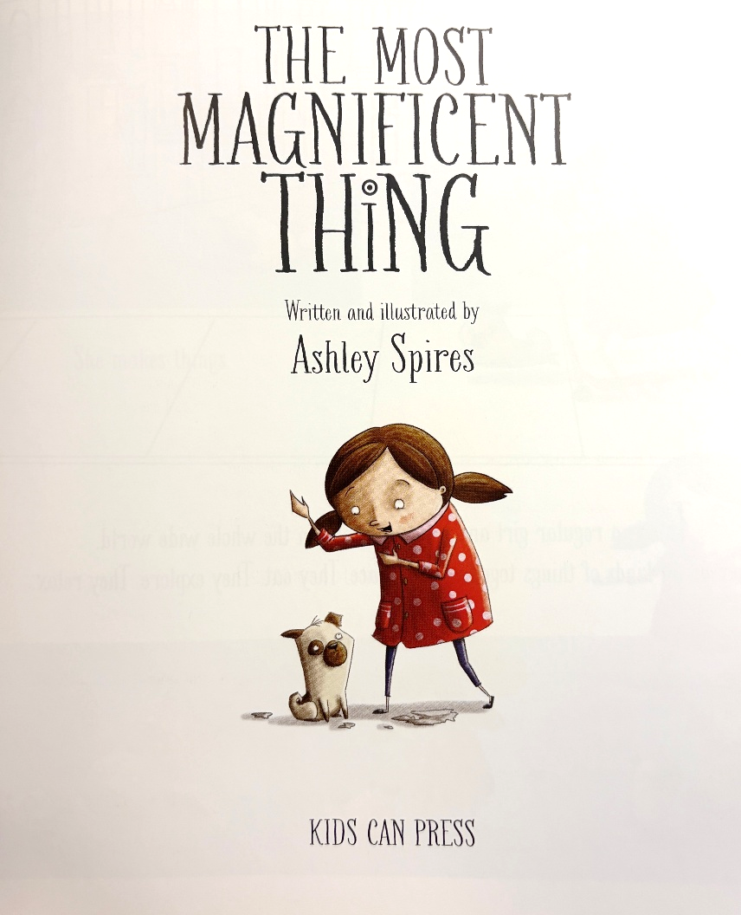

The Most Magnificent Thing
By Ashley Spires

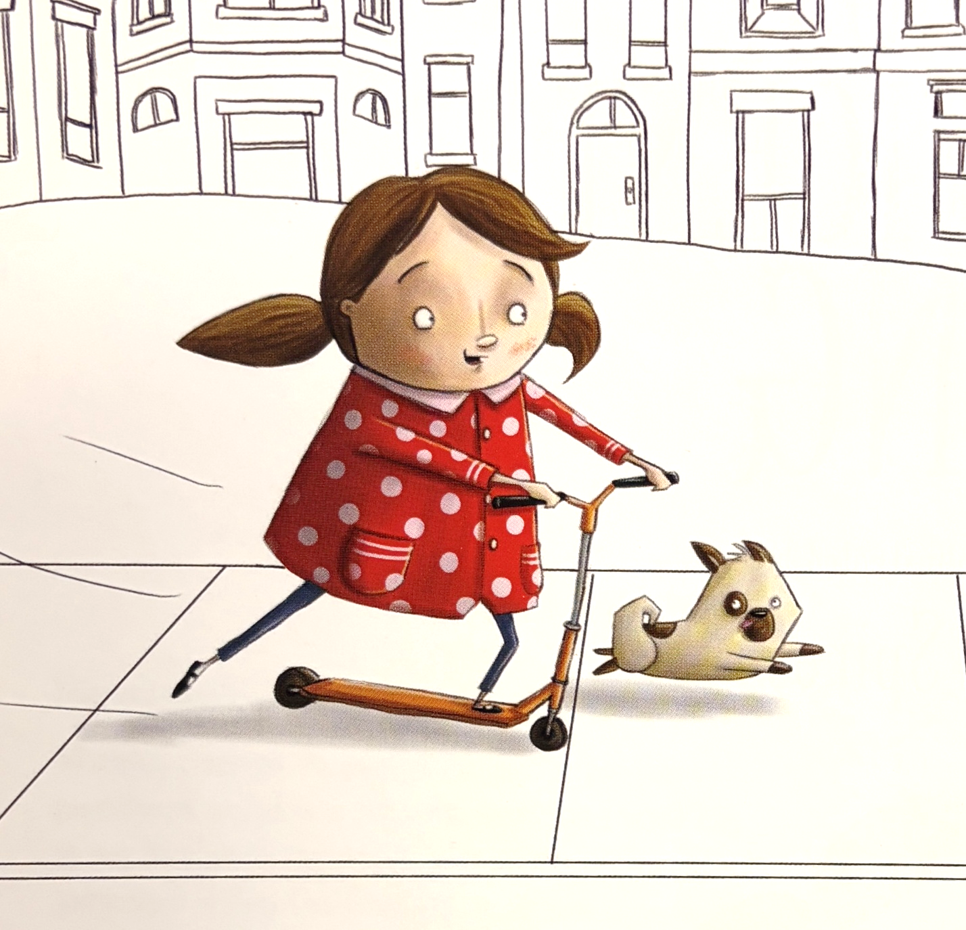

This is a girl and her best friend.

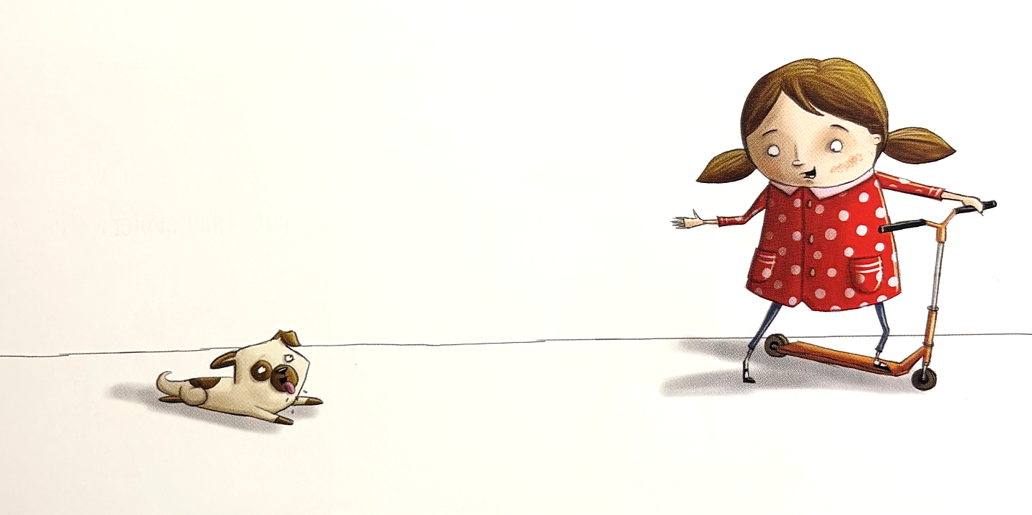

She has an idea.

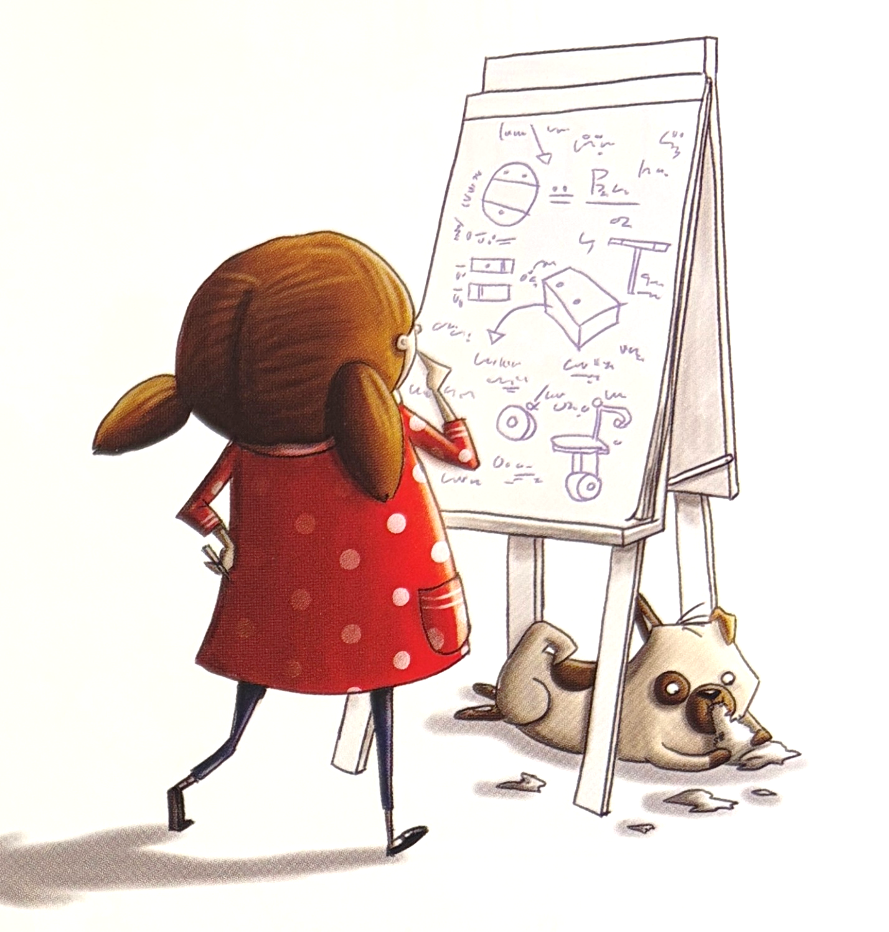

She makes a plan.

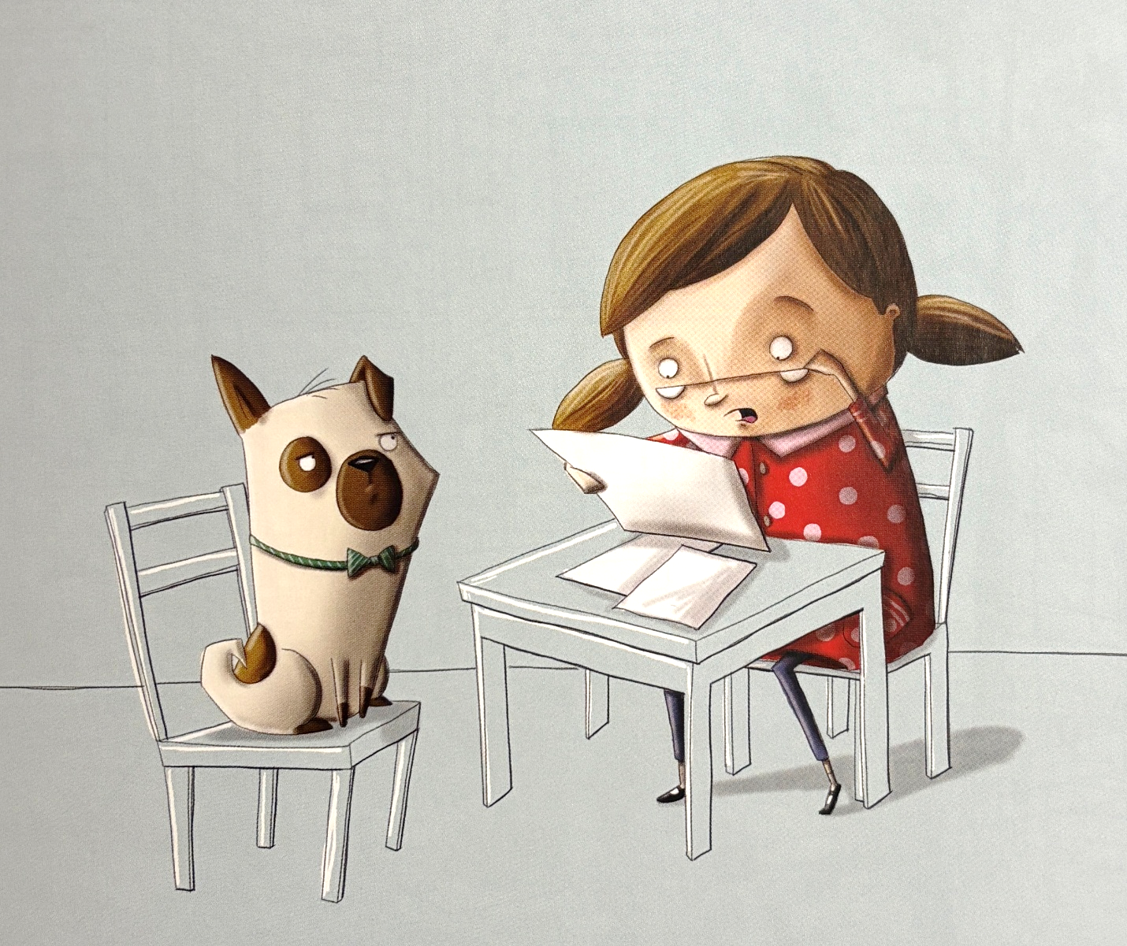

She gets a helper.

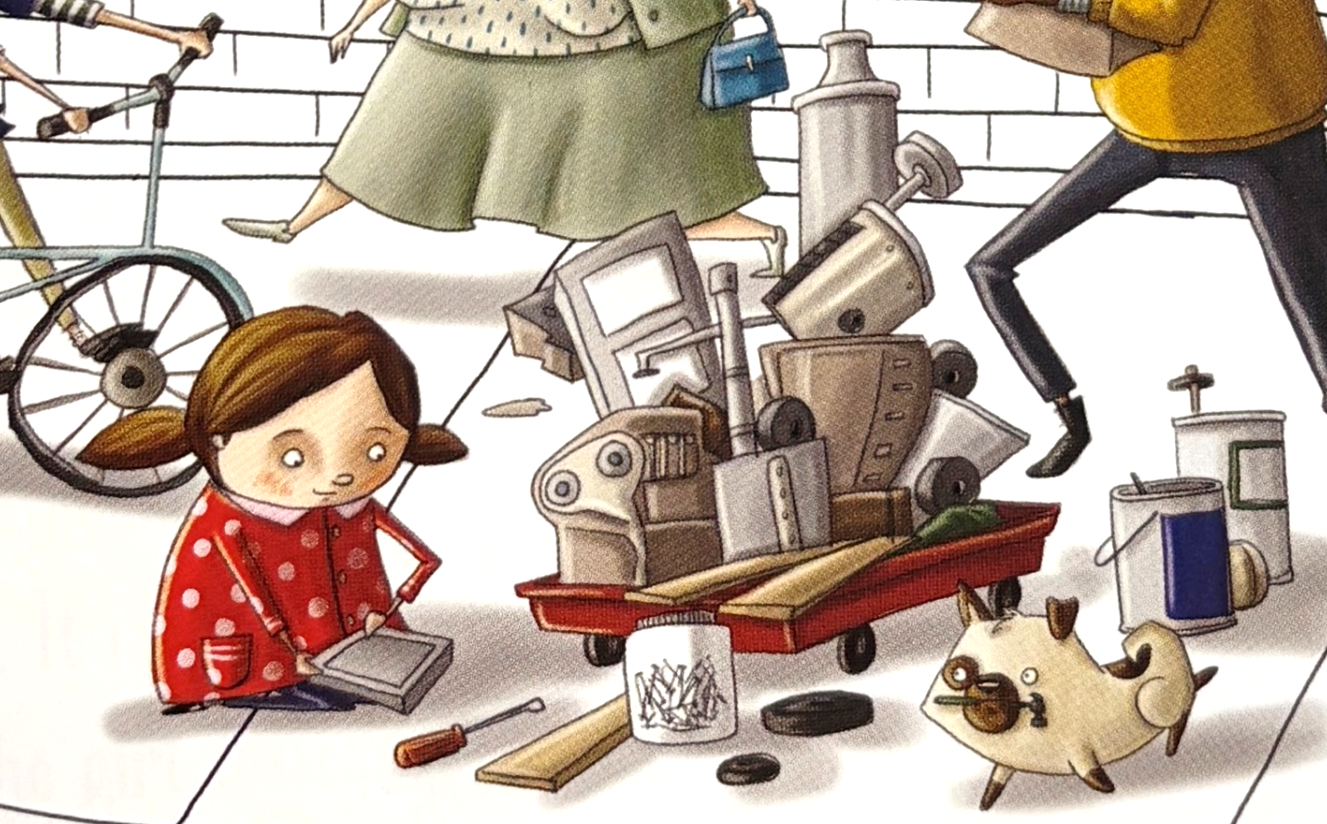

She gets supplies.

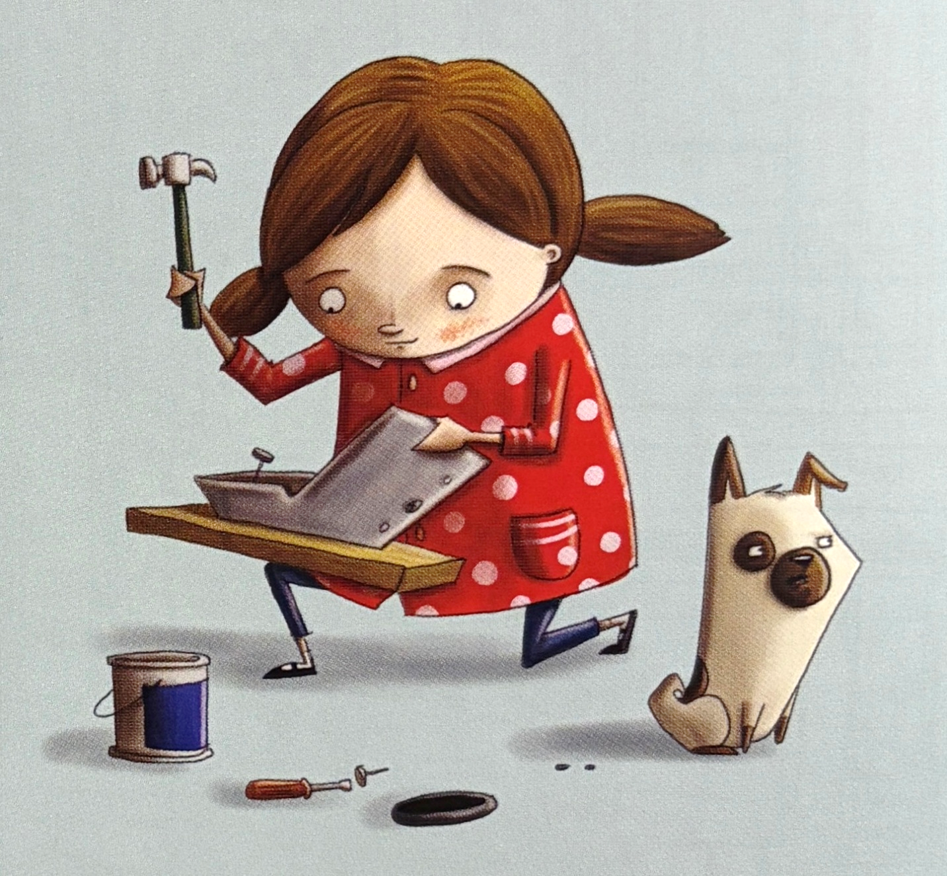

She makes a thing.

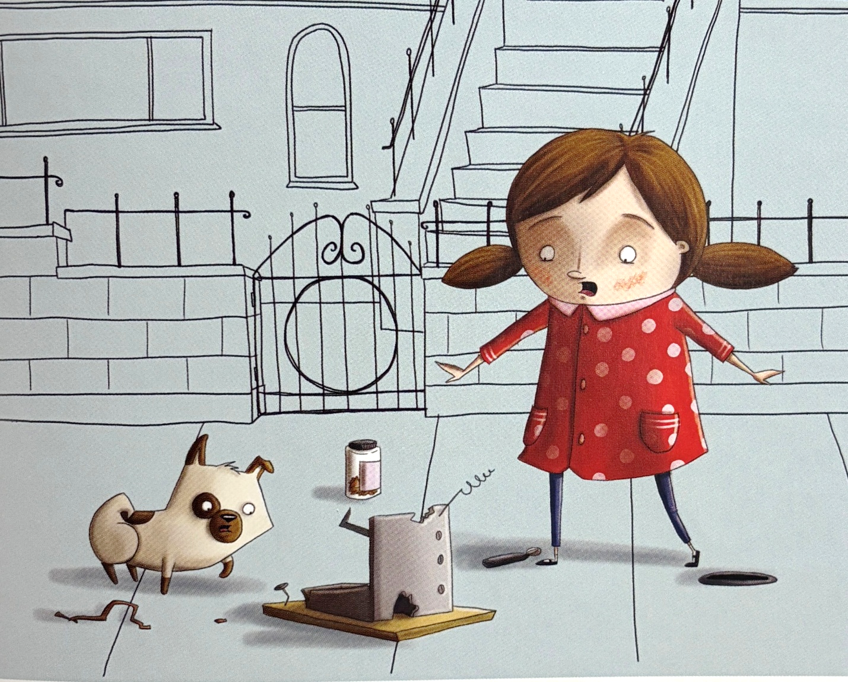

The thing is wrong.

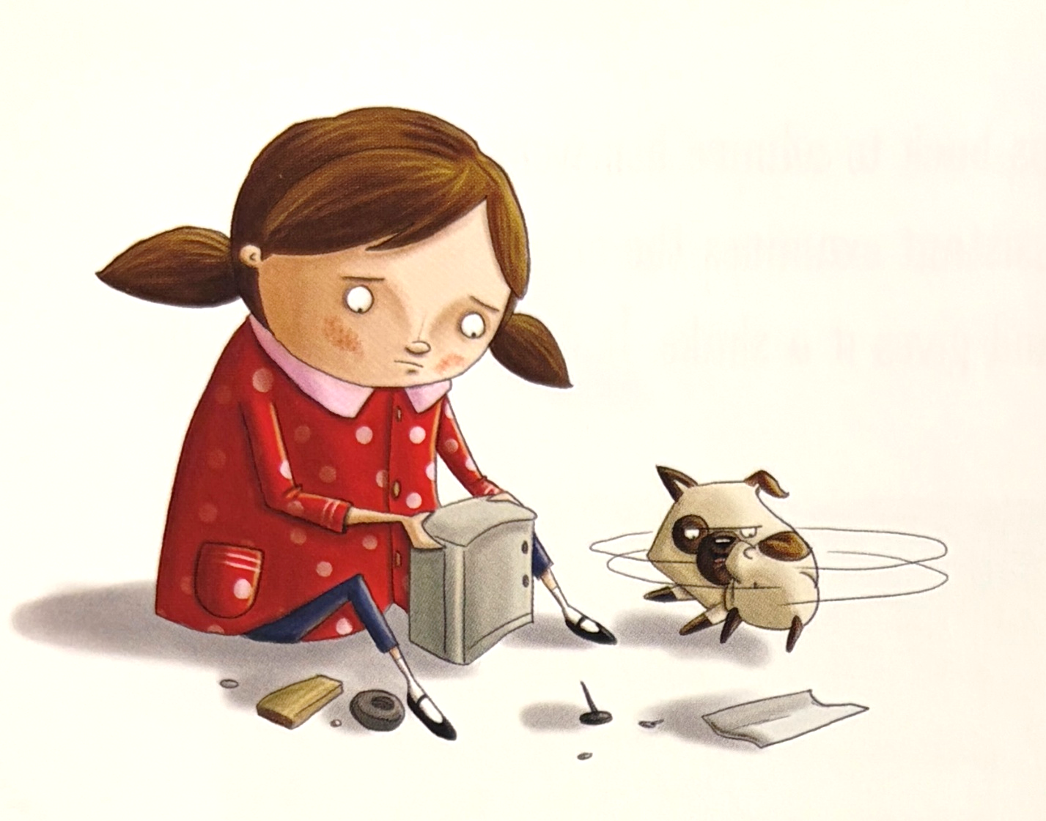

She tries again.

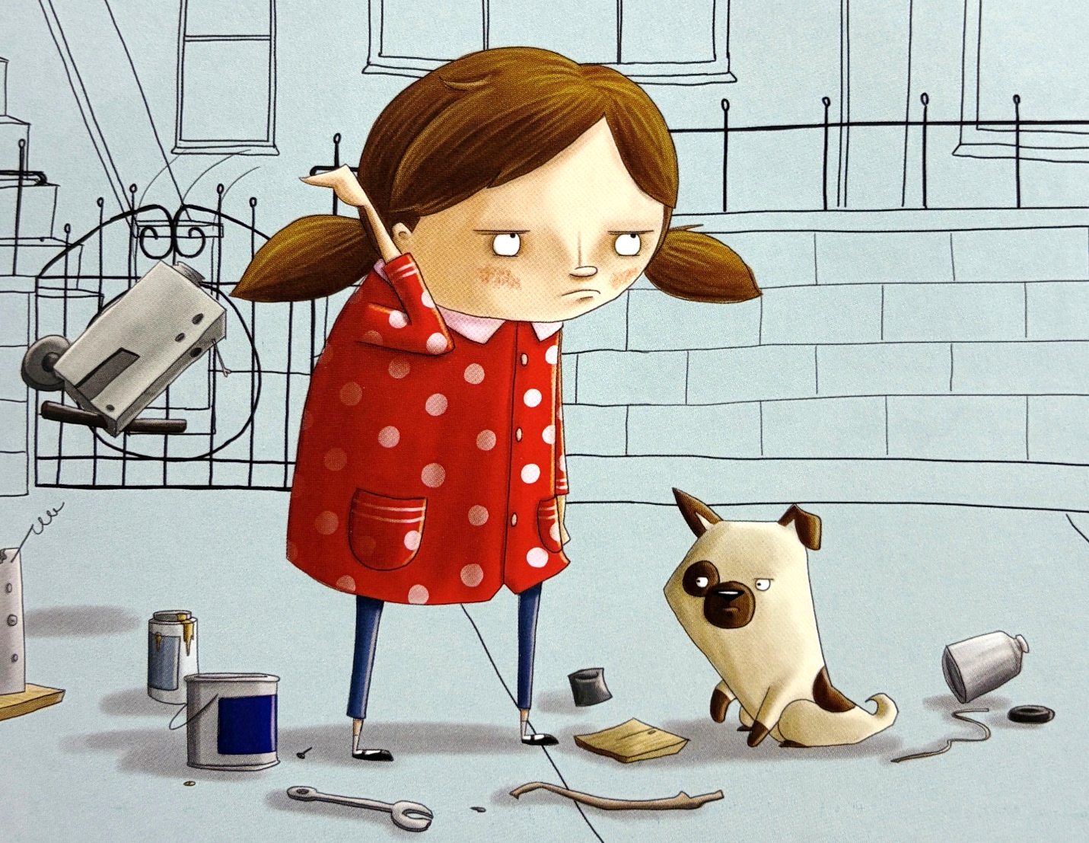

The thing is wrong.

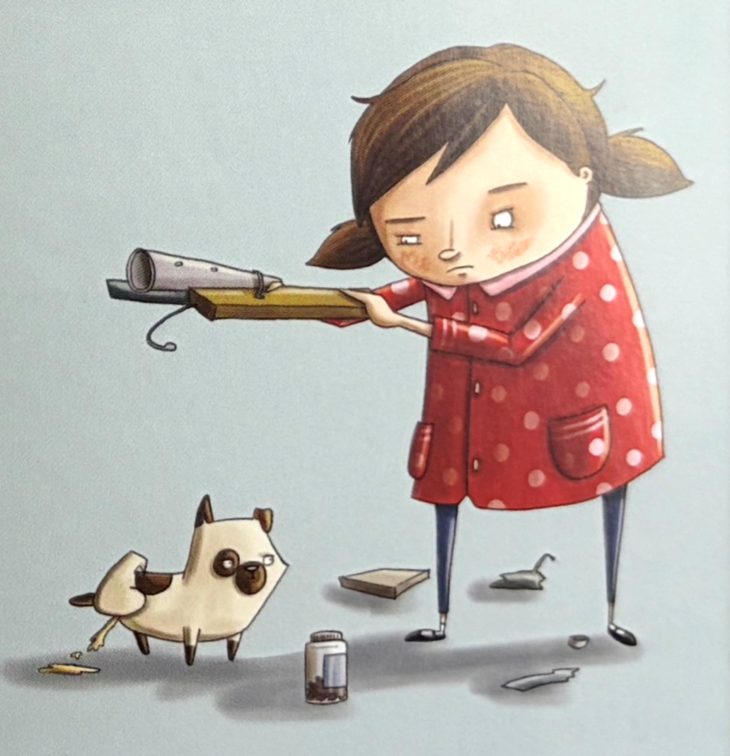

She tries again.

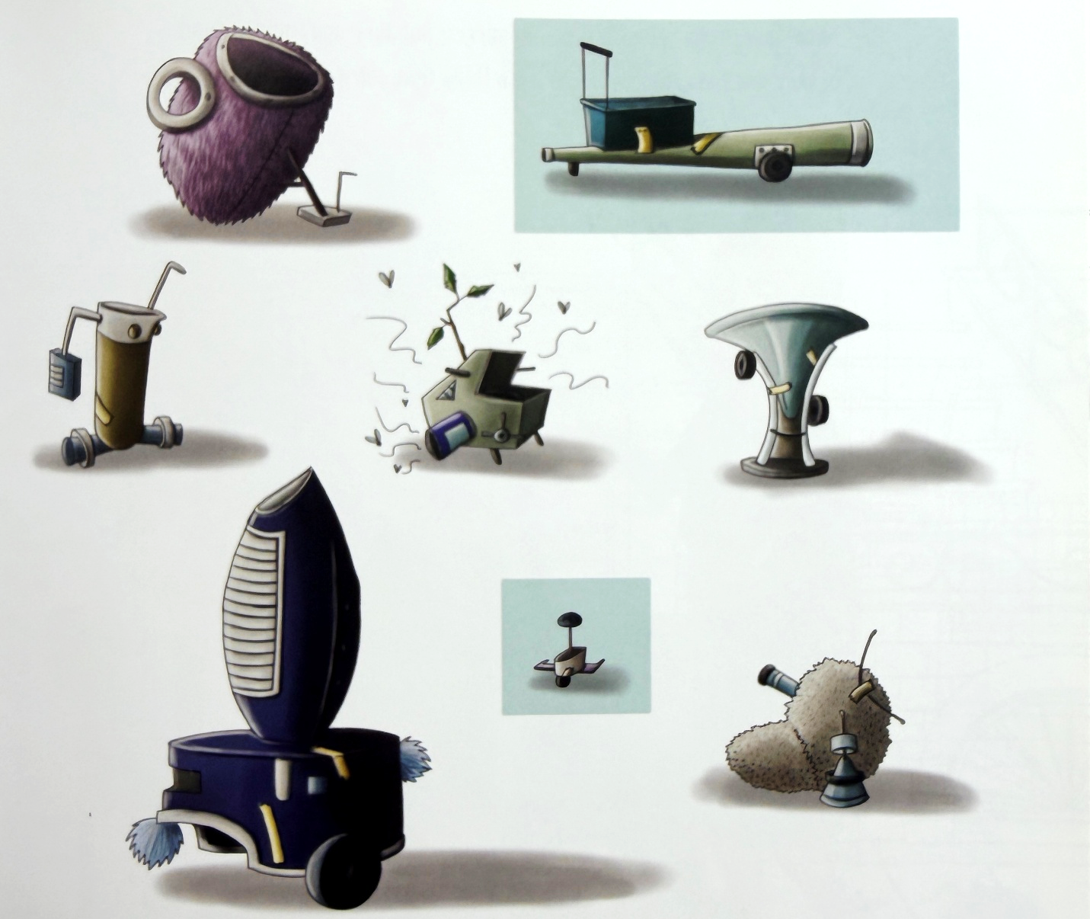

All the things are wrong.

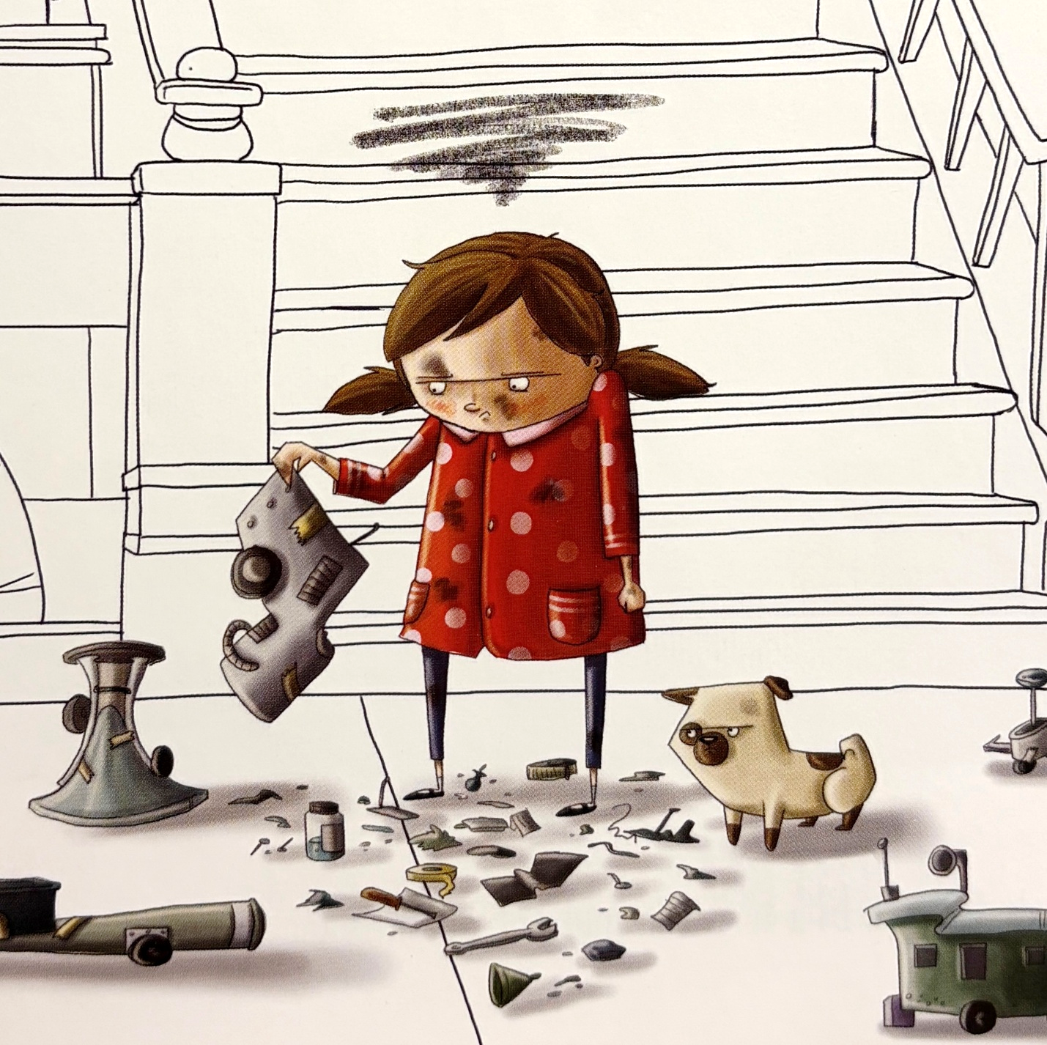

She gets mad.

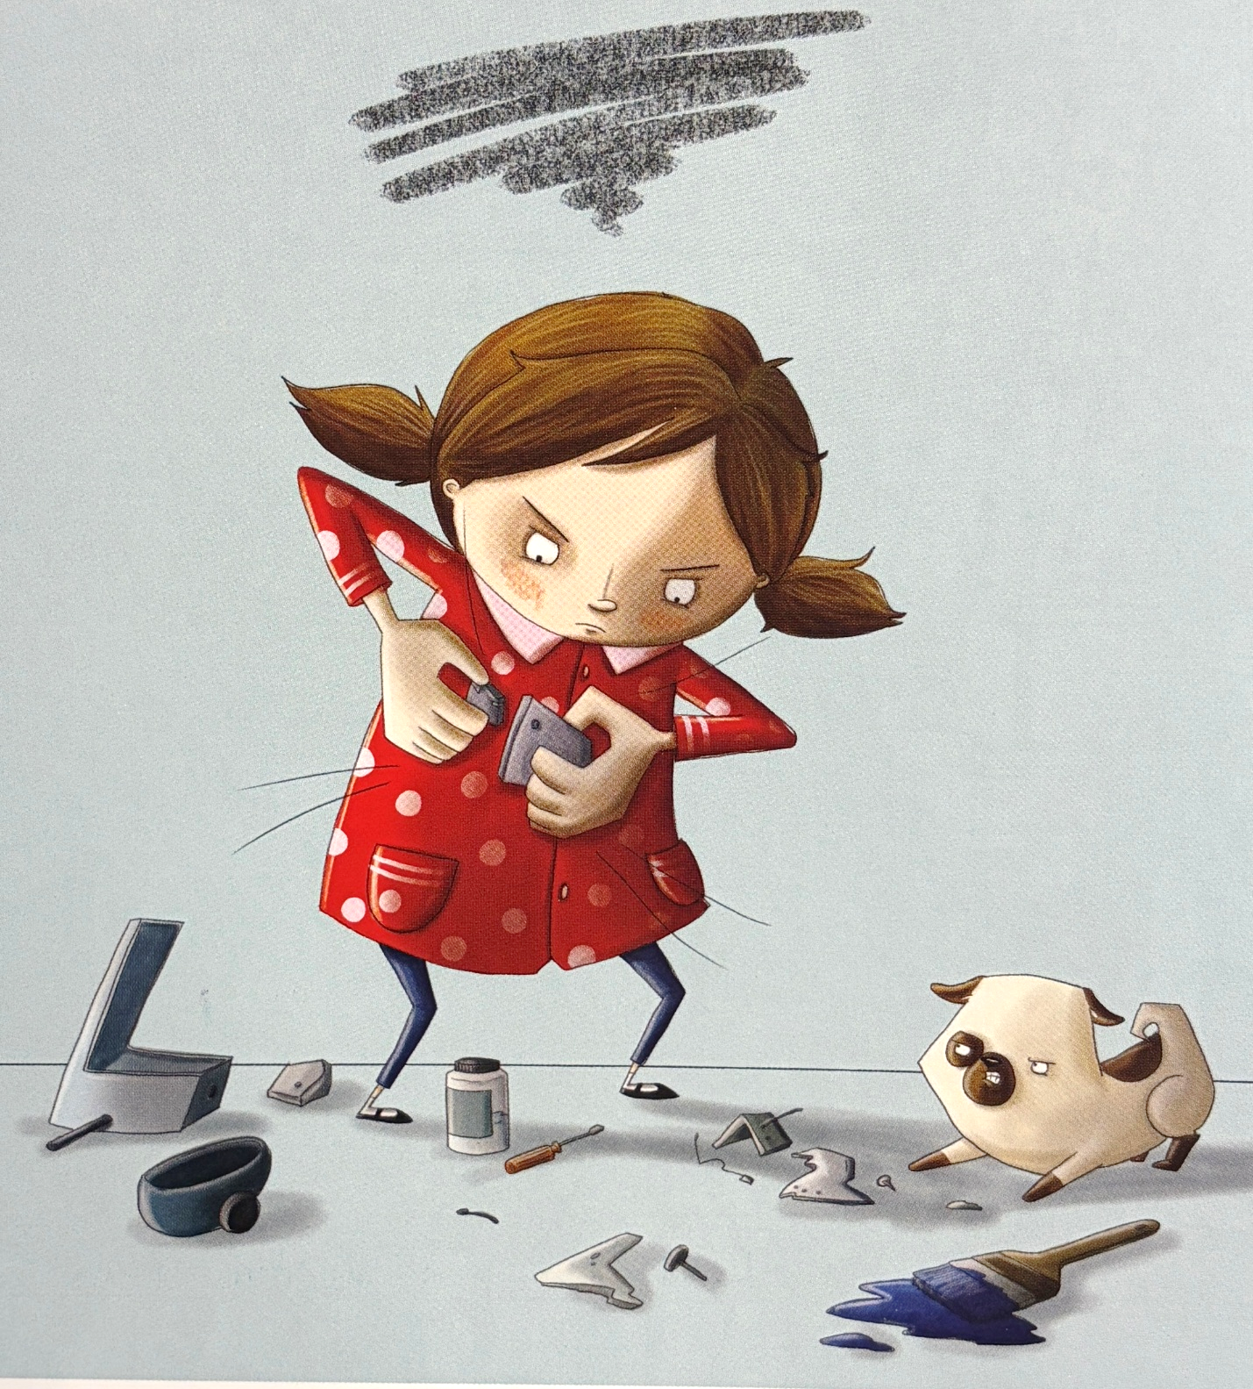

She tries again.

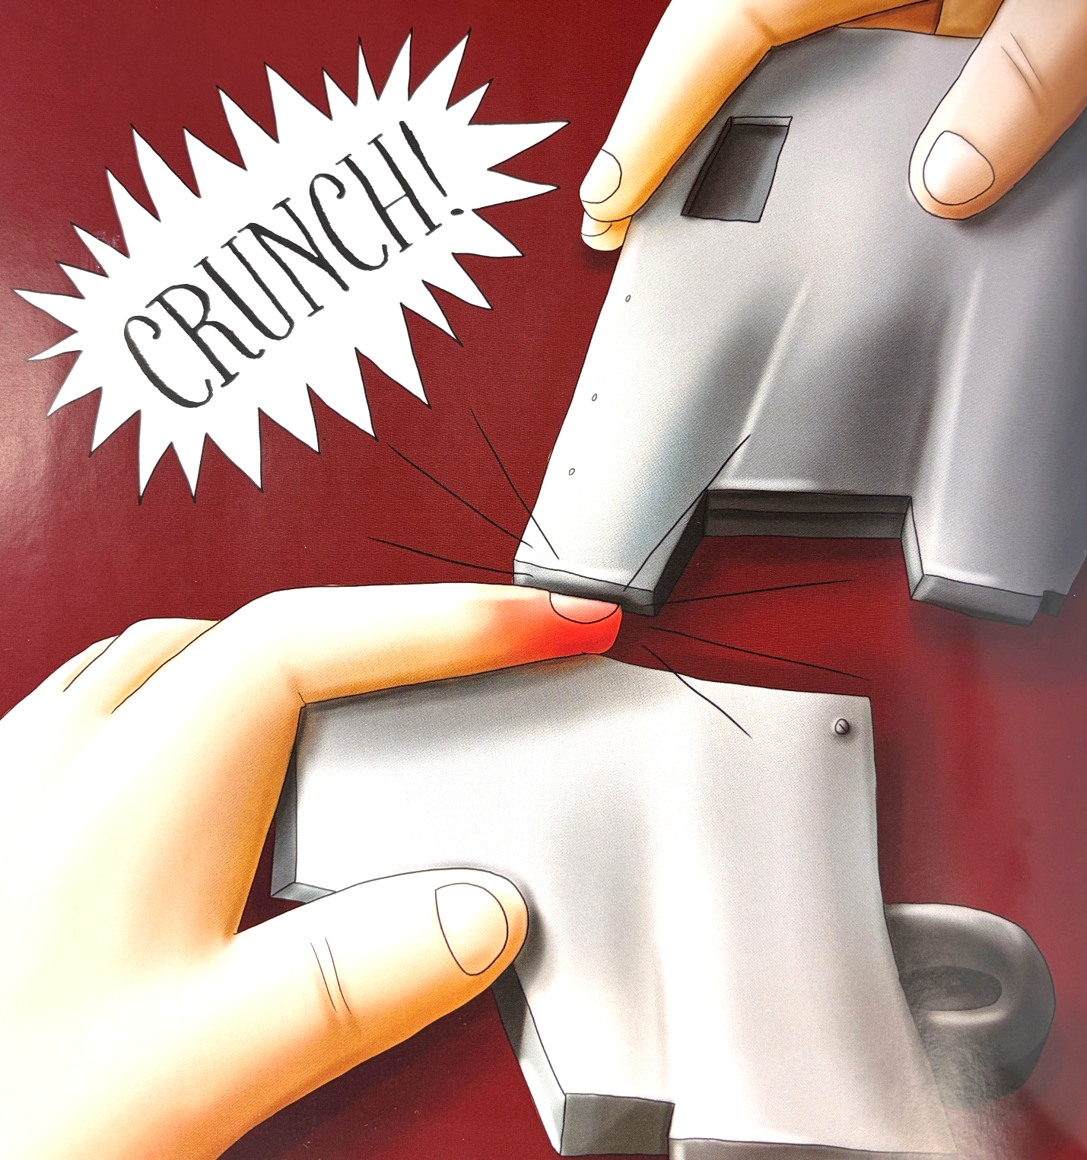

She gets hurt.

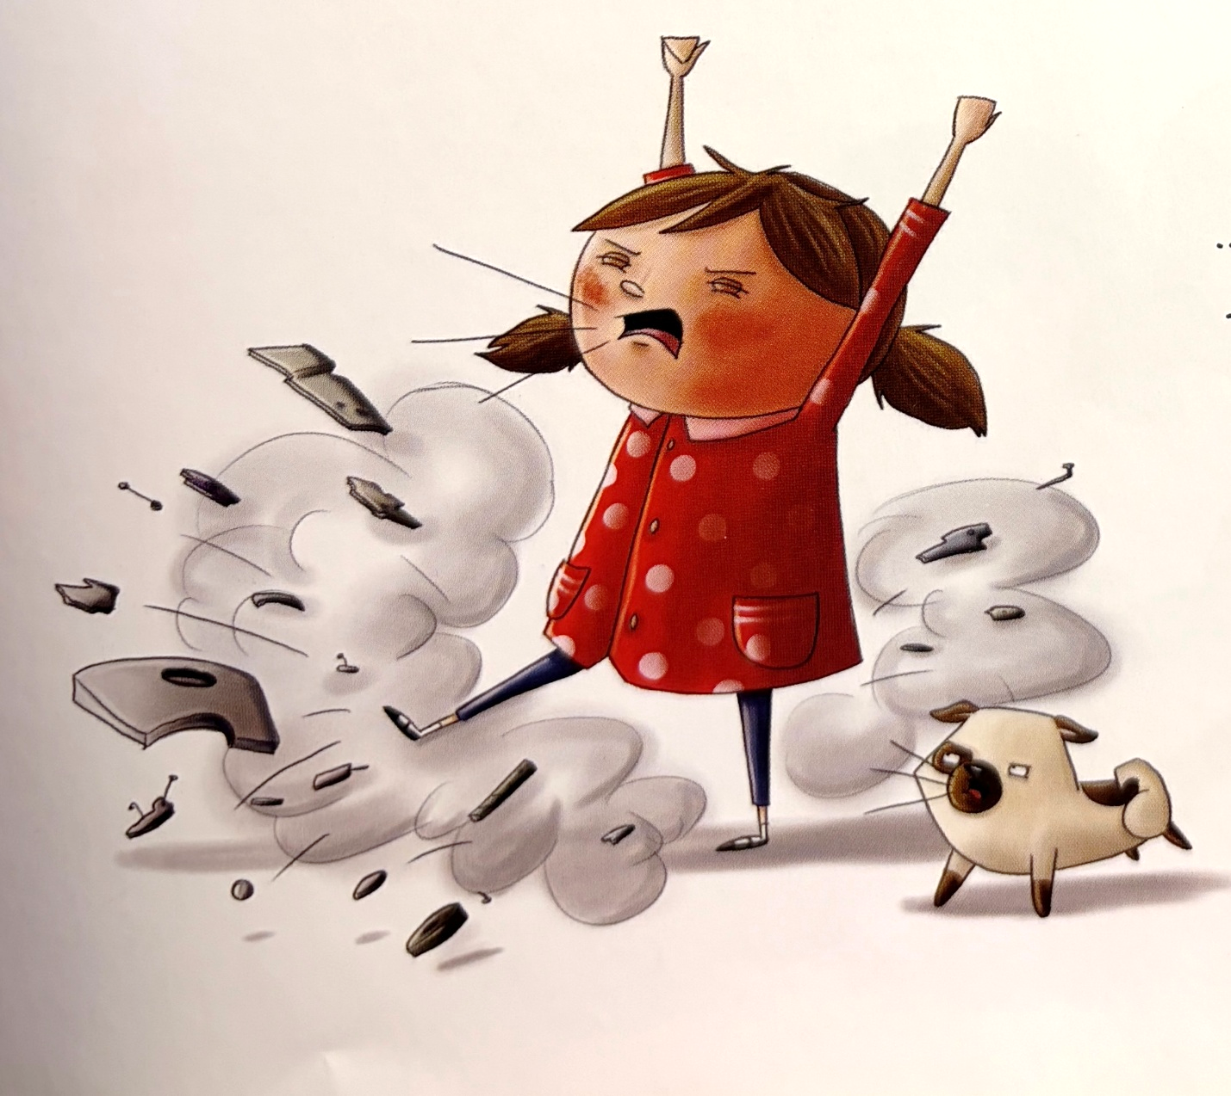

She explodes.

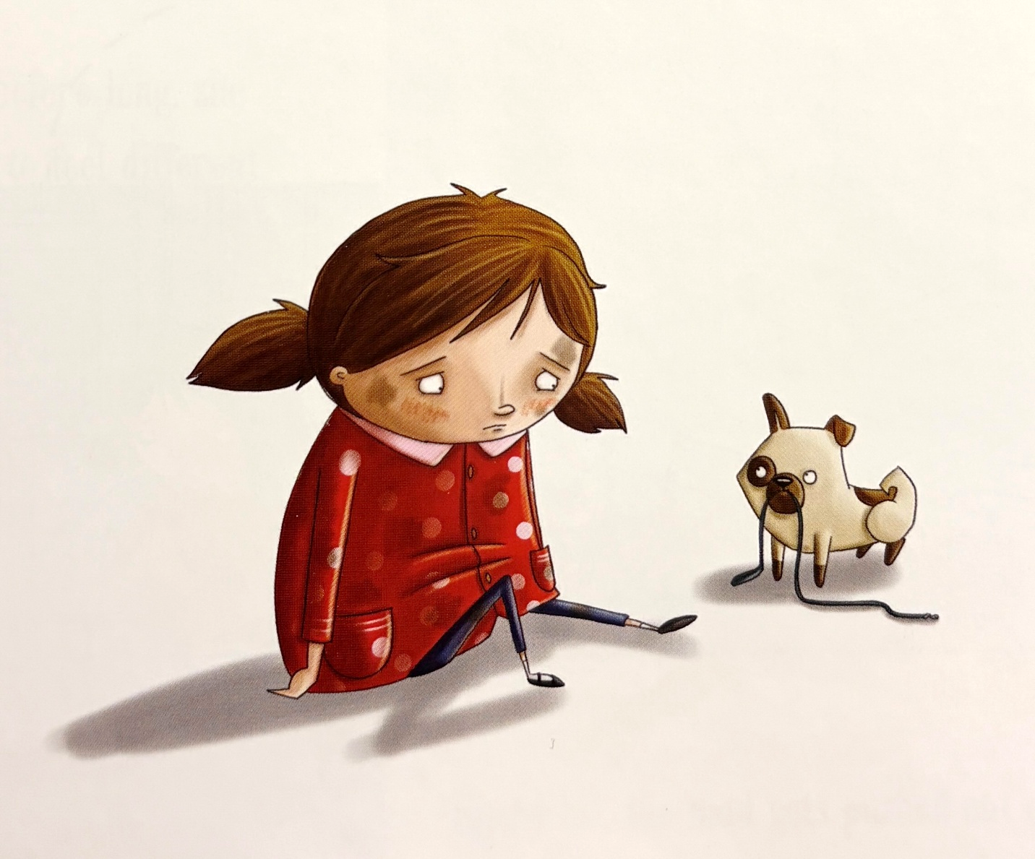

The helper wants a walk.

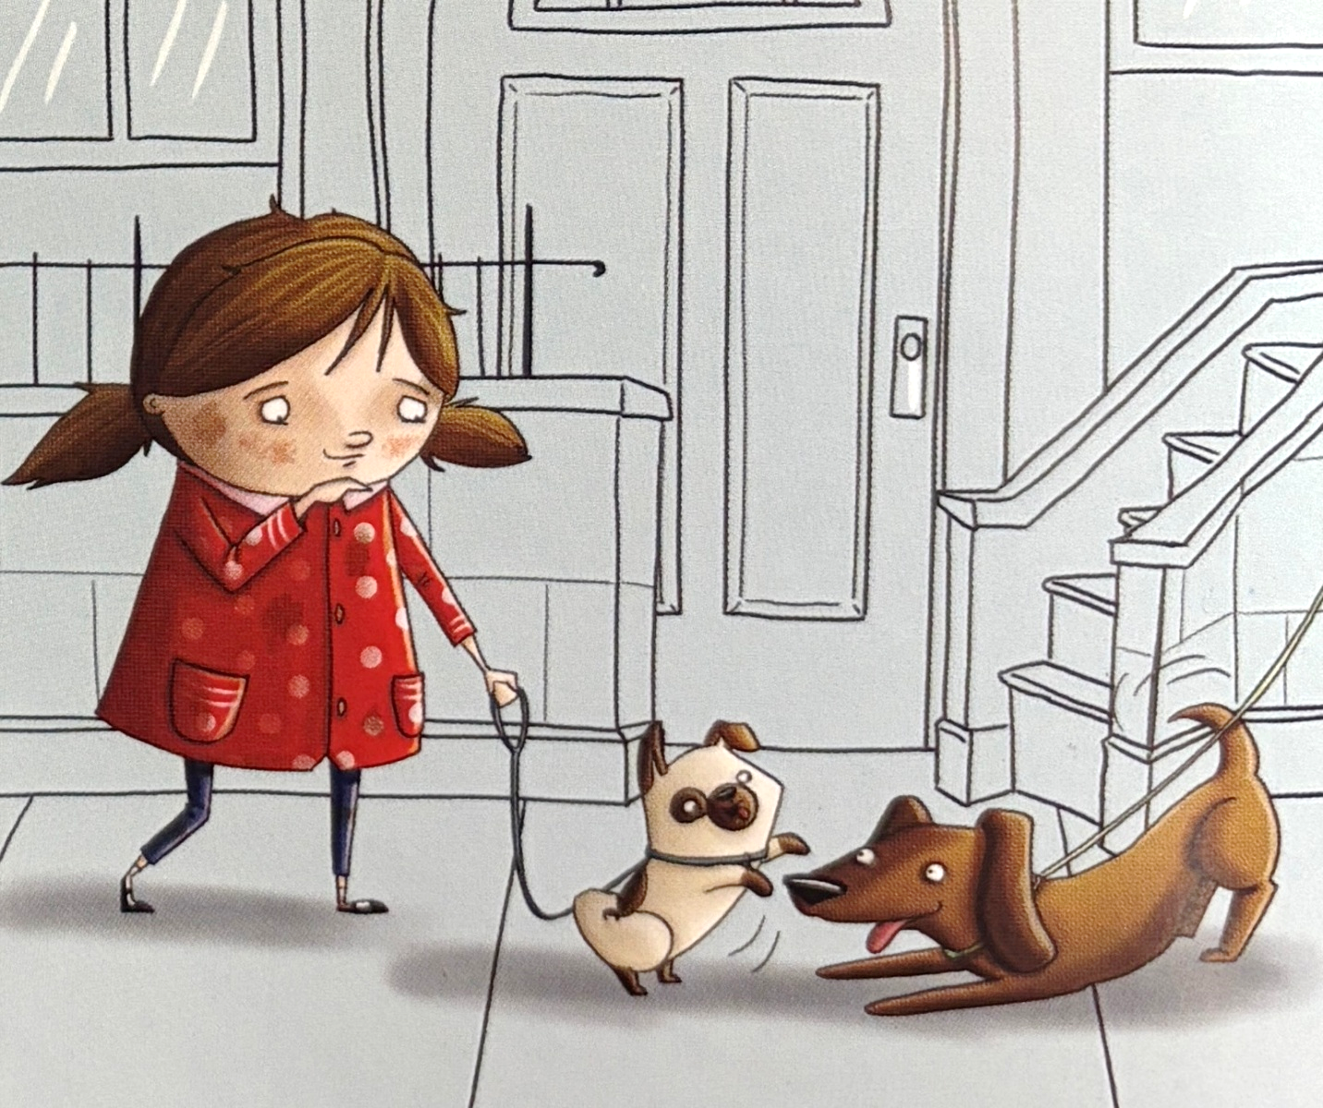

They take a walk.

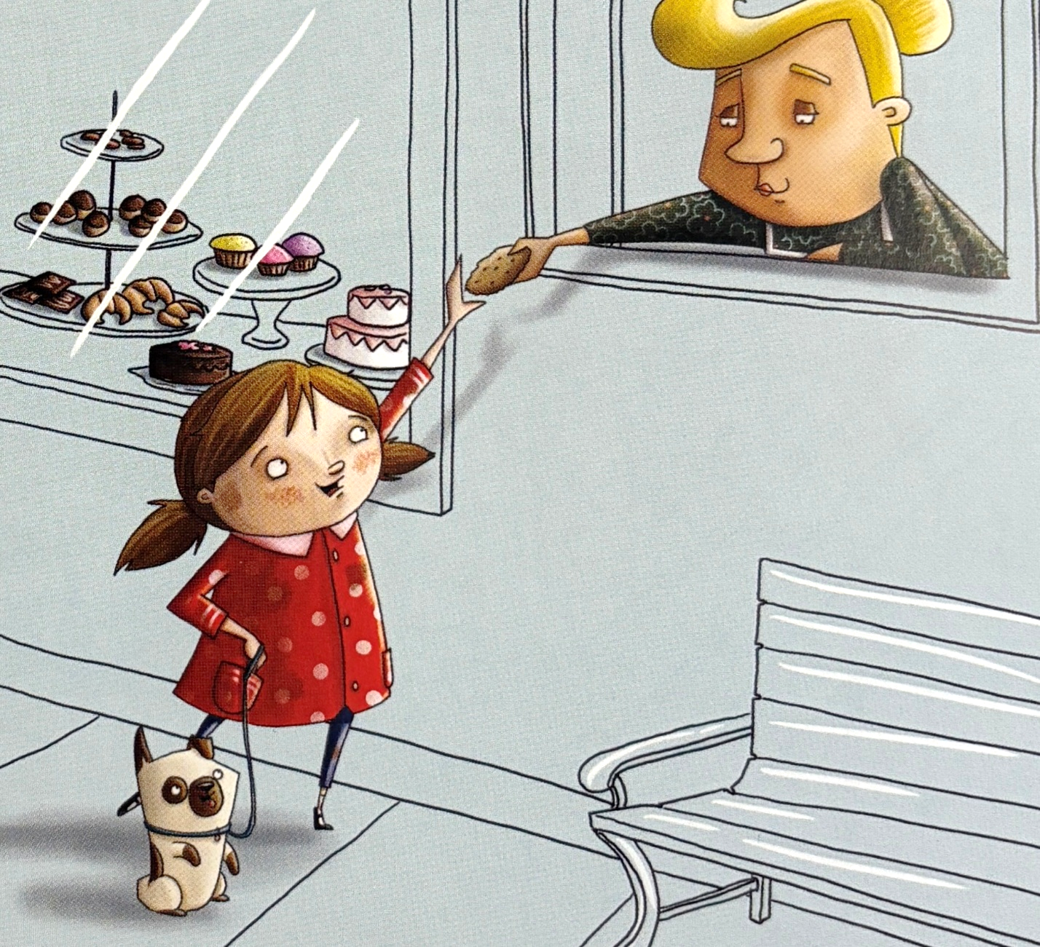

She is not mad.

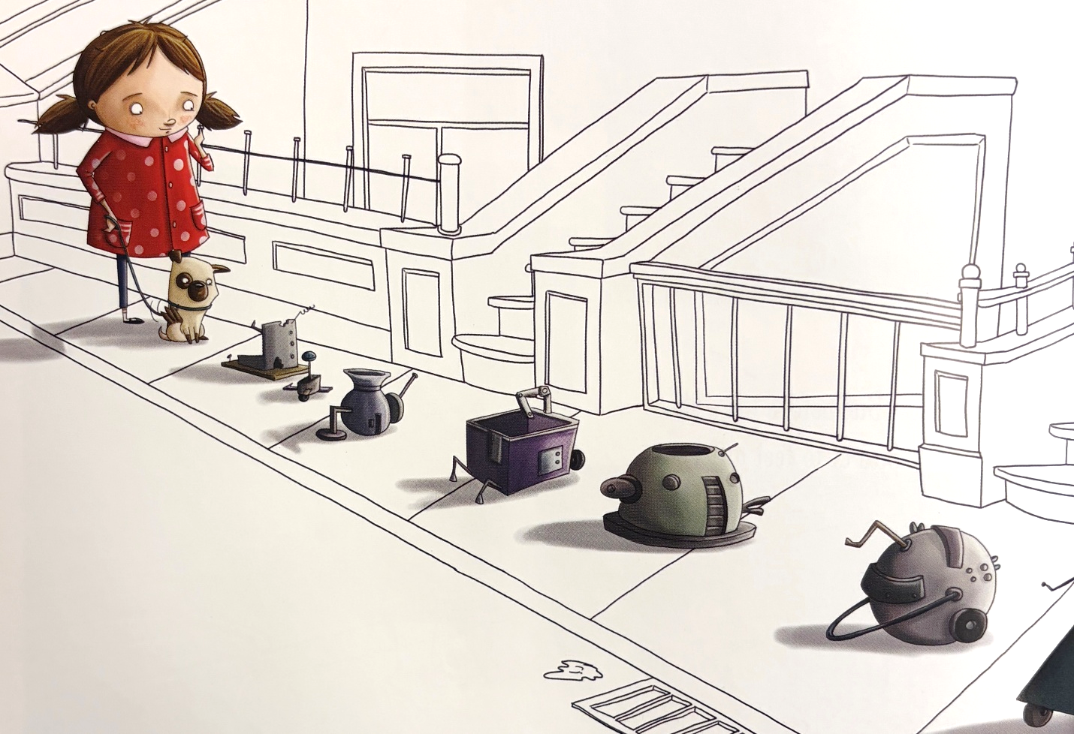

The things have some right parts.

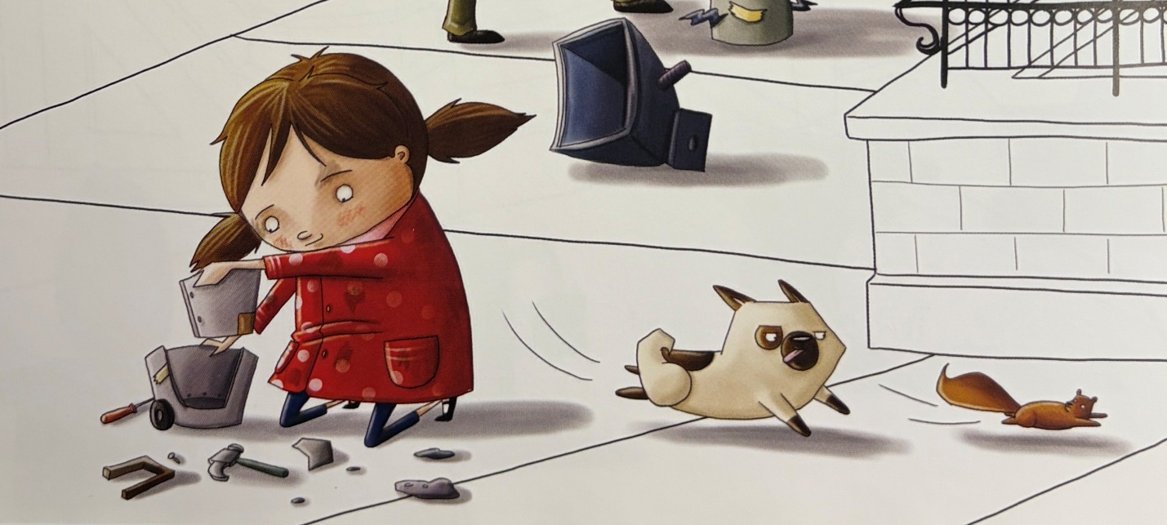

She tries again.

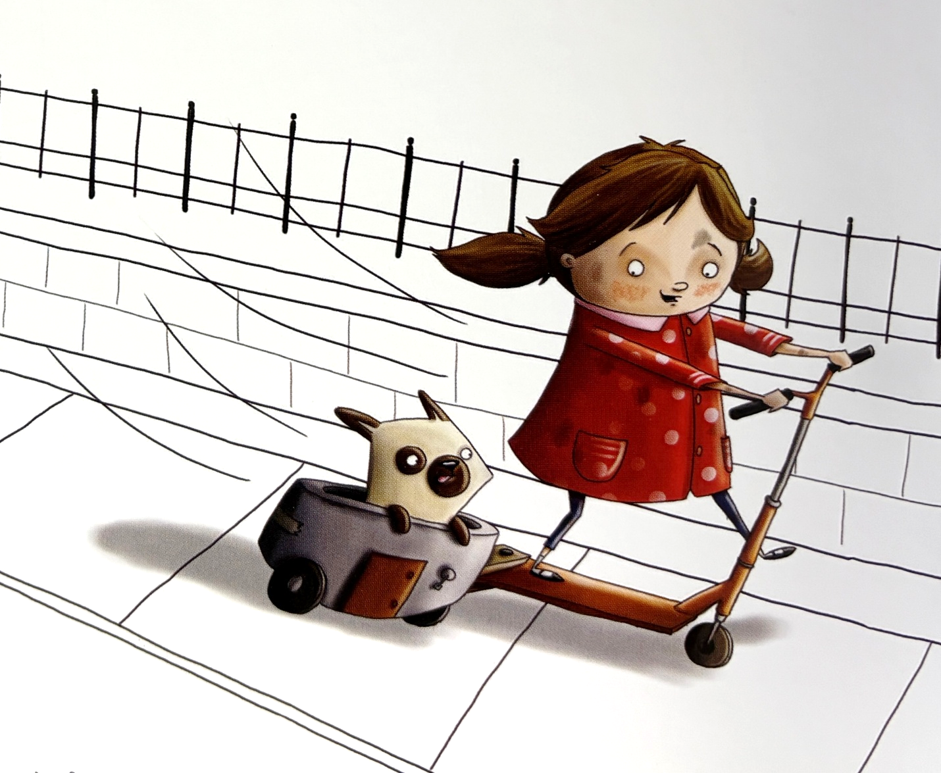

The thing is magnificent.

Disclaimer
This Adapted Literature resource is available through the Paul V. Sherlock Center on Disabilities Resource Library. The text and graphics are adapted from the original source. These resources are provided for teachers to help students with severe disabilities participate in the general curriculum. Please limit the use and distribution of these materials accordingly.

Paul V. Sherlock Center on Disabilities / RI College
600 Mt. Pleasant Avenue, Providence RI 02908 www.sherlockcenter.org

