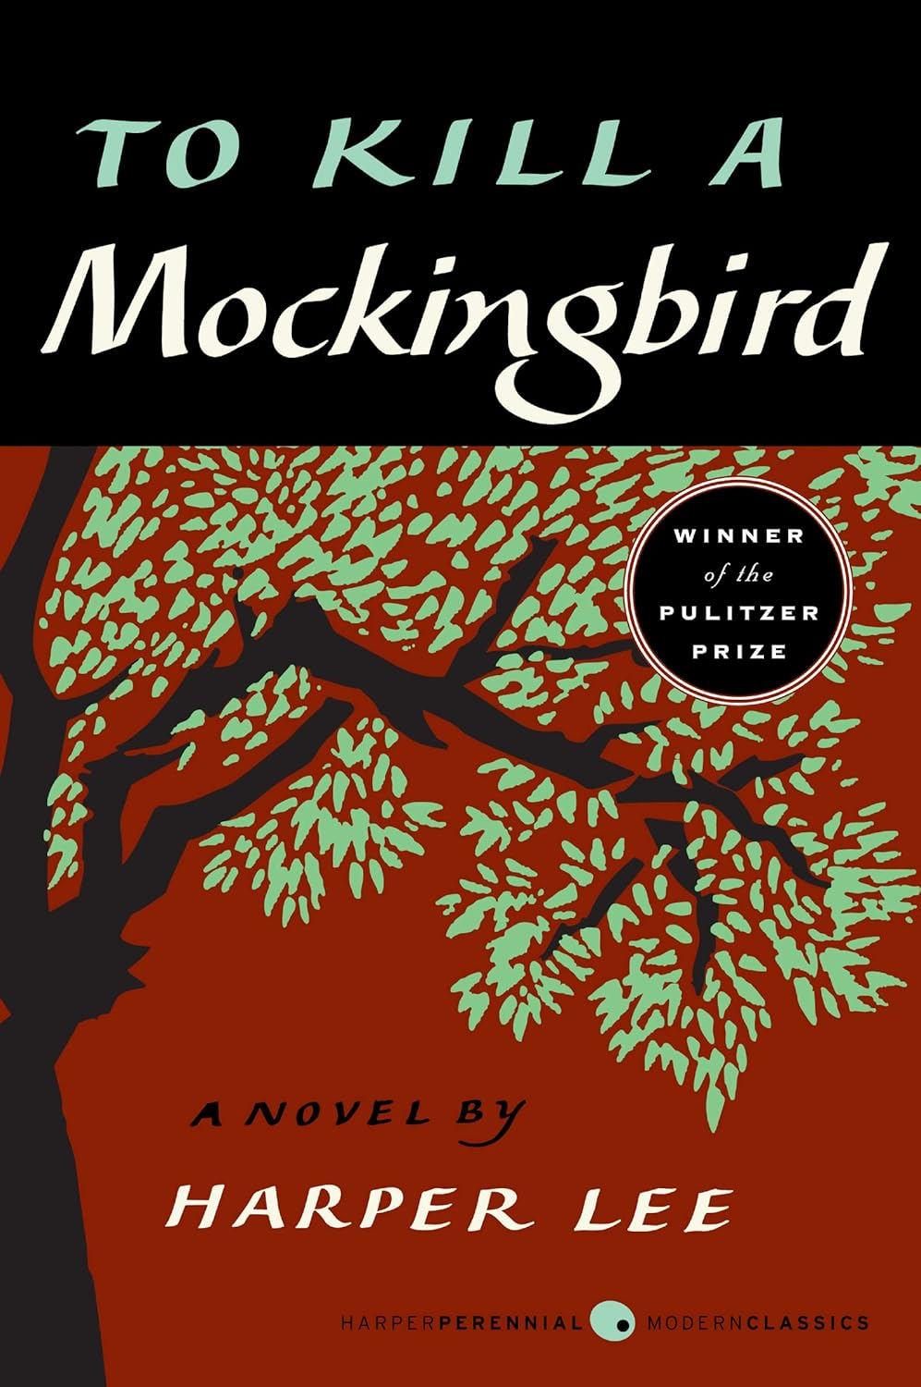
To Kill a Mockingbird

Based on the book by Harper Lee
Adapted by Sherlock Center for use for children with disabilities.



Scout lives in a small town.
Scout wants to do good.



In the town some people look different.
Not everyone is the same.



Some people in the town are mean.
They are mean to people who are different.



Atticus is Scout’s father.
He is a good man.



Atticus has a good job.
At his job he can help people.



Atticus wants to help Tom.
Tom is in trouble because he is different.



Tom did not do anything wrong.
Atticus can tell people the truth.



People do not believe Atticus.
They hurt Tom because he is different.
Scout and her brother are sad.

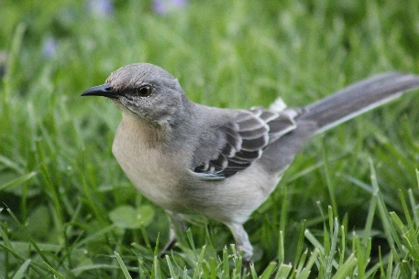

Atticus says Tom is like a bird.
Birds make the world good.
Tom made the world good.

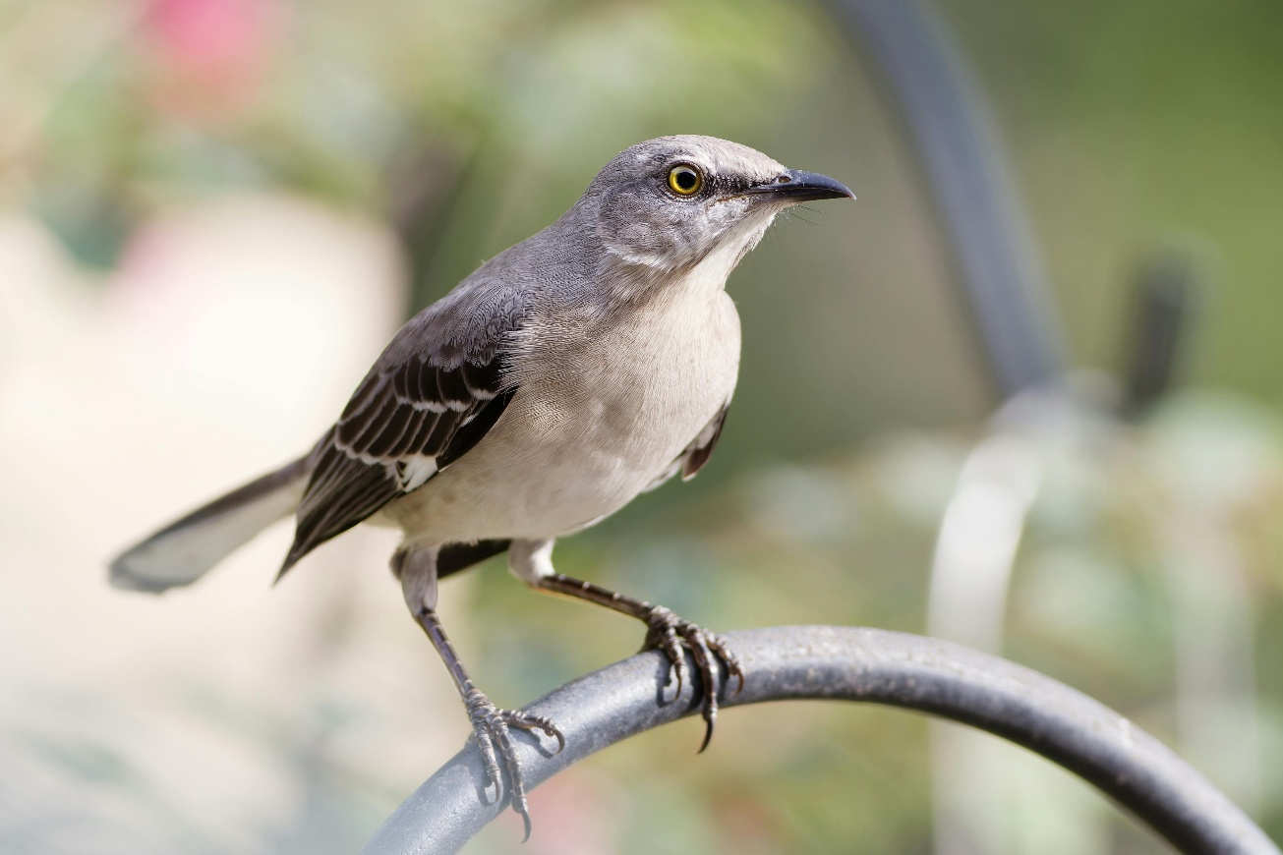

Hurting a bird is not good.
Hurting Tom is not good.



Scout is different from the town.
She wants to do good.
She likes people who are different.

Disclaimer
This Adapted Literature resource is available through the Paul V. Sherlock Center on Disabilities Resource Library. The text was adapted from the original source. Copyright free graphics have been used. These resources are provided for teachers to help students with severe disabilities participate in the general curriculum. Please limit the use and distribution of these materials accordingly.

Photos from Pexels:
- Scout: https://www.pexels.com/photo/close-up-shot-of-a-woman-wearing-headphones-6187667/
- Men in white shirts: https://www.pexels.com/photo/a-group-of-men-wearing-white-shirt-9775880/
- Girl being bullied: https://www.pexels.com/photo/diverse-male-teenagers-bullying-anonymous-lady-covering-face-with-hands-6147113/
- Atticus, p. 5: https://www.pexels.com/photo/man-sitting-at-a-table-and-signing-a-document-8729721/
- Atticus, p. 6: https://www.pexels.com/photo/a-man-working-in-the-office-8730850/
- Atticus and Tom: https://www.pexels.com/photo/a-two-men-looking-the-digital-tablet-8729810/
- Scout and Jem: https://www.pexels.com/photo/a-girl-and-a-boy-wearing-black-clothes-sitting-next-to-each-other-6187678/
- Atticus, p. 8: https://www.pexels.com/photo/portrait-of-a-businessman-8937579/
- Mockingbird, p. 10: https://www.pexels.com/photo/photo-of-a-grey-mockingbird-on-green-grass-7324868/
- Mockingbird, p. 11: https://www.pexels.com/photo/grey-bird-perched-on-metal-bar-14731610/
- Hands: https://www.pexels.com/photo/symbol-of-unity-and-diversity-hands-together-36686749/

Paul V. Sherlock Center on Disabilities / RI College
600 Mt. Pleasant Avenue, Providence RI 02908 www.sherlockcenter.org

