Seedfolks Guide

Pictures, Objects, Textures, Sensory:
- Setting: Cleveland, OH- Textured map of Ohio with textured star for Cleveland’s location, Garden- Garden tool
- Main characters: Kim- enlarged picture with textured hair, Gonzalo- a tie, Anna-Glasses
- Trash: balled up paper and foil to represent the trash in the park
- Seeds: Lima Beans, pumpkin, lettuce, hot peppers, tomatoes, flowers, radishes, eggplant
- Gardening tools: shovel, watering can, gloves
- Soil
- water

Sign Language:
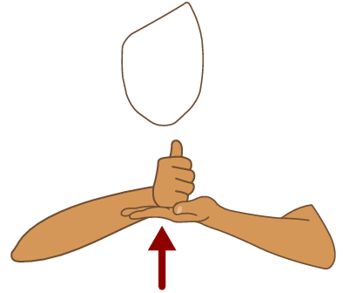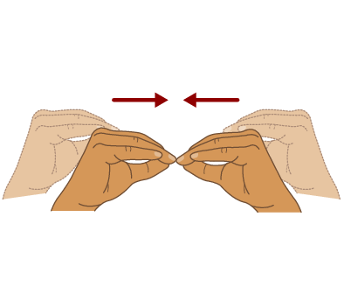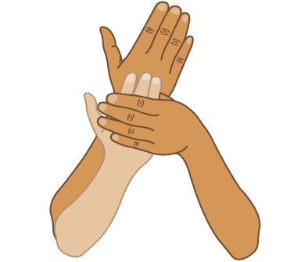
help more grow

Project Core Words:
- Help
- See
- More

Additional Activities
- Have students grow their own garden. Have them feel/look at the different seeds to choose what they would like to grow.
- Sequence the steps to growing a garden
- Try different experiments with plants
- Visit the community garden in their community (if available)
- Make recipes using some of the items that were planted in the story
- Create a textured representation of the different parts of a plant
- Sensory box with soil, gardening tools, etc.

